University Of Engineering and Technology, Lahore Computer Engineering Department

Course Name: PF | Course Code: CMPE-112L
Assignment Type: LAB | Dated: 18 May 2026
Semester: 1st | Session: 2026 Spring
Lab/Project/Assignment #: 8 | CLOs to be covered: CLO
Lab Title: Dictionaries and Sets | Teacher Name: Hafiz Muhammad Mubashar

Lab Evaluation:

CLO1 | Apply appropriate programming techniques to create executable programs to solve well defined problems
 | Level1 | Level2 | Level3 | Level4 | Level5 | Level6
(5)
Total |  |  |  |  |  | /5

Rubrics for Current Lab Evaluation

Scale | Marks | Level | Rubric
Excellent | 5 | L1 | Submitted all lab tasks, BONUS task, have good understanding.
Very Good | 4 | L2 | Submitted the lab tasks but have good understanding
Good | 3 | L3 | Submitted the lab tasks but have weak understanding.
Basic | 2 | L4 | Submitted the lab tasks but have no understanding.
Barely Acceptable | 1 | L5 | Submitted only one lab task.
Not Acceptable | 0 | L6 | Did not attempt

LAB No 8

Lab Goals/Objectives:
- Understand the concept of Sets and Dictionaries in Python.
- Learn how to store and manage data using sets and key–value pairs.
- Create programs using set operations and dictionary methods.
- Understand accessing, updating, and manipulating data collections.

Equipment Required:
- Computer/Laptop

- Python IDE
- Python Interpreter

Theory:
A dictionary is an unordered collection of data stored in key : value pairs.Key Points:Mutable : You can add, remove, or change itemsKeys must be unique and immutable : int, string, tupleValues can be anything : int, string, list, dict, etcAccessed by key, not by indexSyntax : dict = {"name": "Ali", "age": 20}

Lab Work:

Task 1:
Create a dictionary with English words as keys and their Urdu translations as values. Access and print the translations for "apple" and "mango". Then add a new pair "dates":langoor" and print the updated dictionary.
Result:
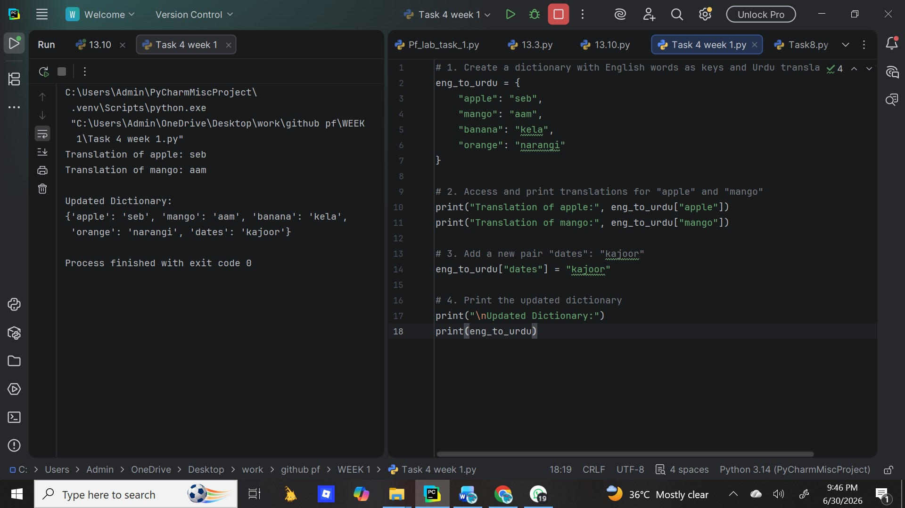

Task 2:
Create a dictionary with at least 3 key-value pairs (like fruits and their translations). Access and print the value of only one specific key using square bracket notation.

Result:
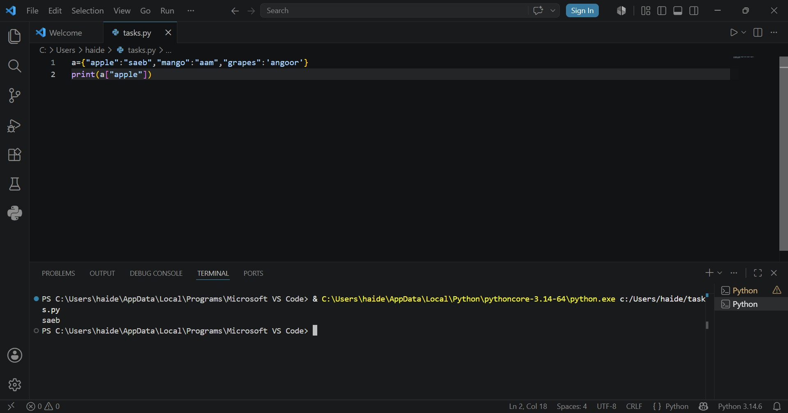

Task 3:
Write a Python program to create a dictionary of student information and demonstrate the use of the following dictionary functions: keys(), values(), items(), get(), update(), pop(), and clear(). Display the output after each operation.

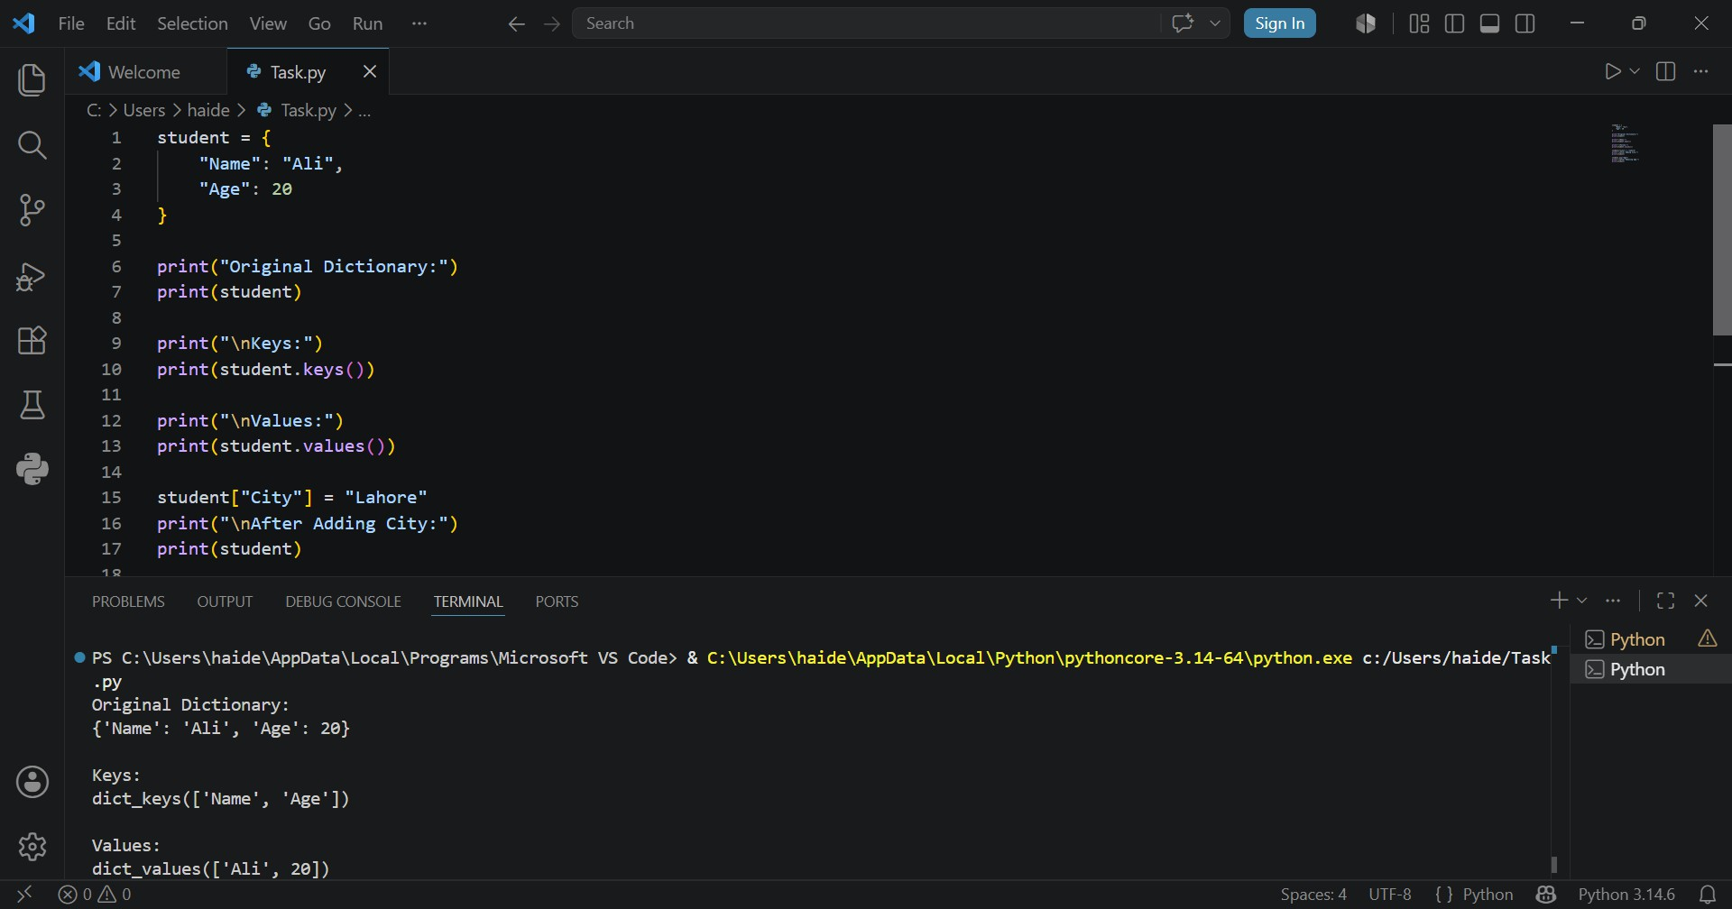
Result:

Task 4:
Create an empty set and an empty dictionary. Print both their types to show the difference between them.
Result:
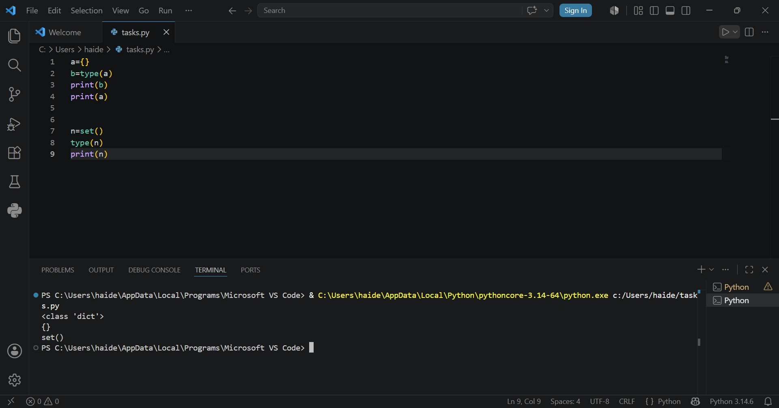

Task 5:
Create a set with some names. Ask the user to input a name and check if it exists in the set, printing an appropriate message.

Result:
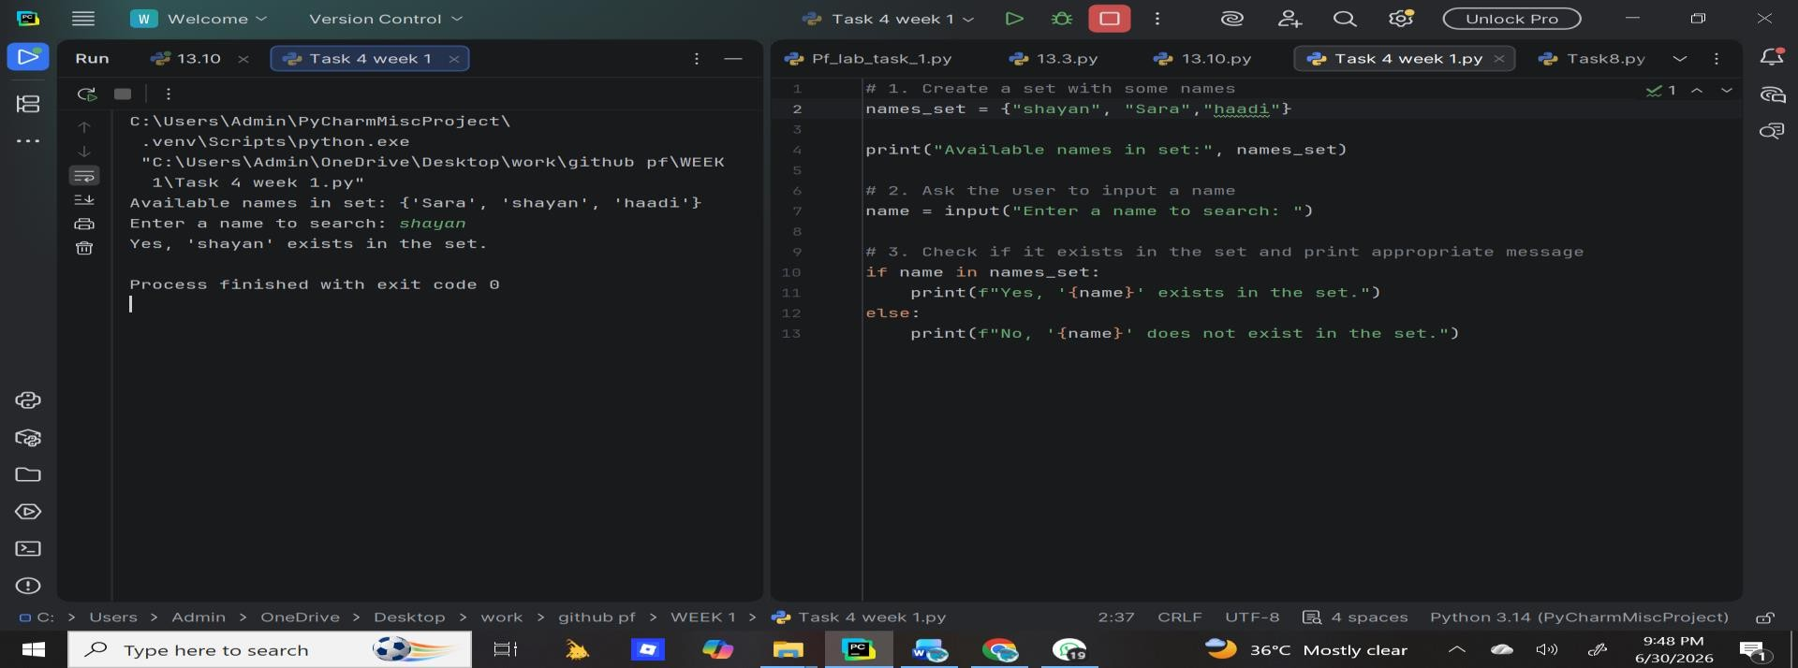

Task 6:
Create a set with initial elements. Add a new element, remove an existing element, and try to remove a non-existent element using the discard() method (which won't raise an error). Print the final set.
Result:

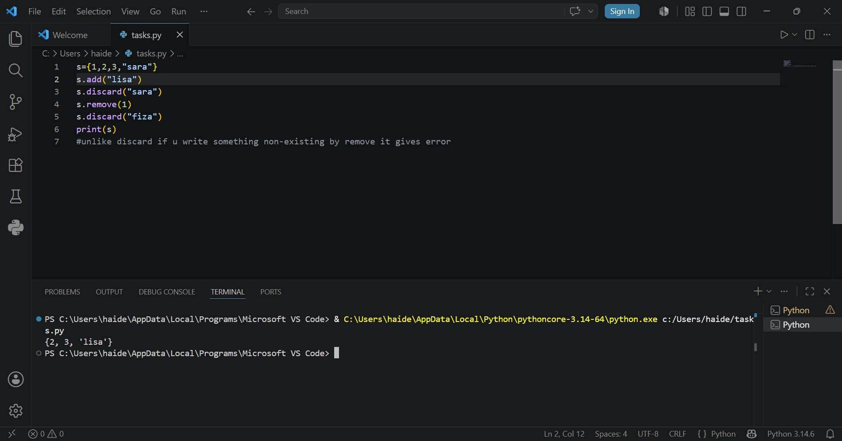
Task 7:
Create a set with some elements. Remove a random element using pop(), print the remaining set, then clear all elements and print the empty set.

Result:
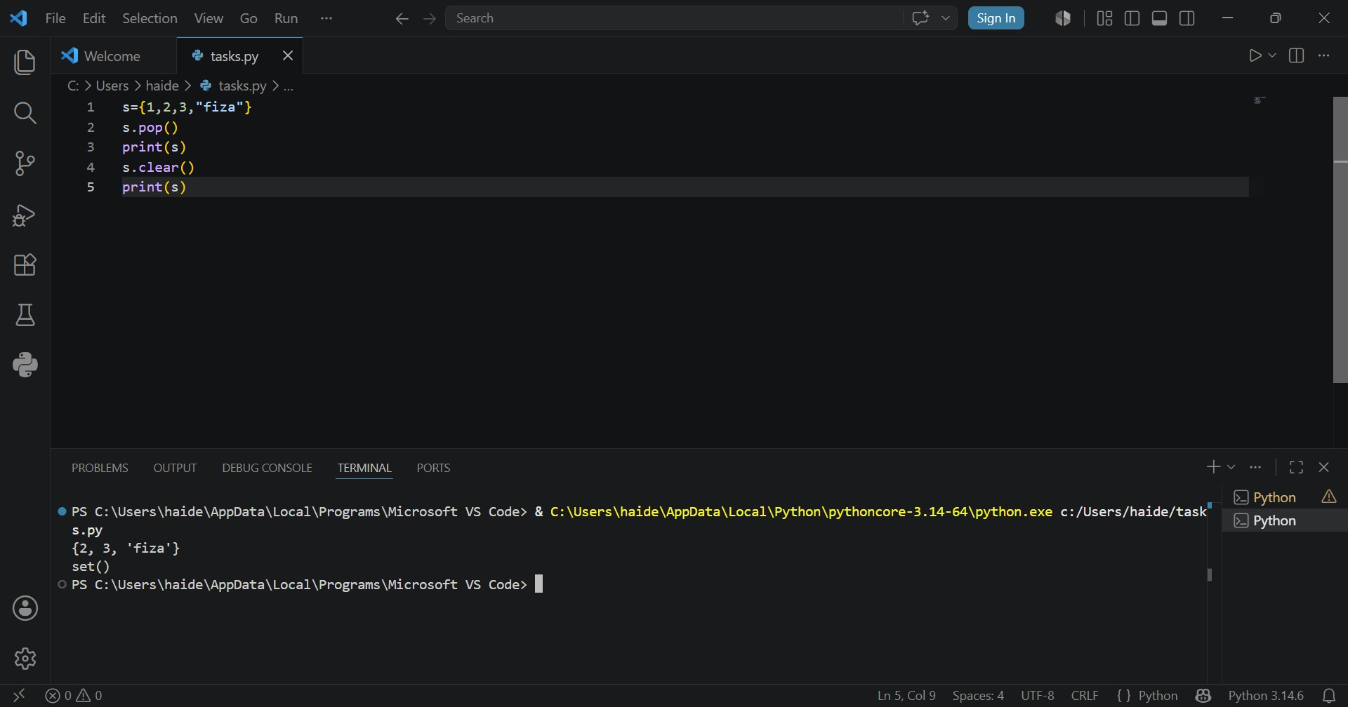
Task 8:
Create three sets and find their union using set.union() method. Print the result.

Result:
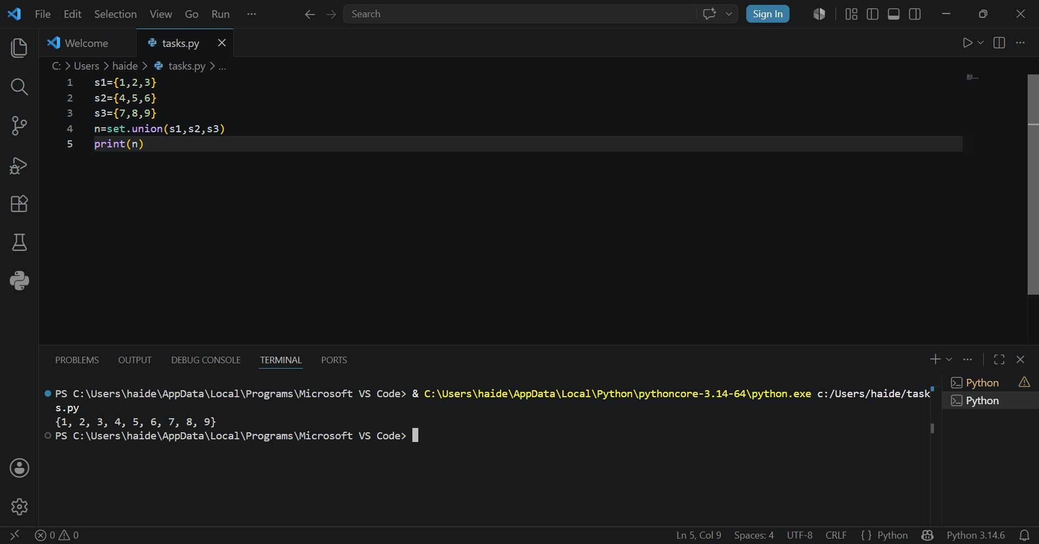

Task 9:
Create three sets. Update the second set with elements from the third set, then update the first set with elements from the updated second set. Print all three sets to see the changes.
Result:
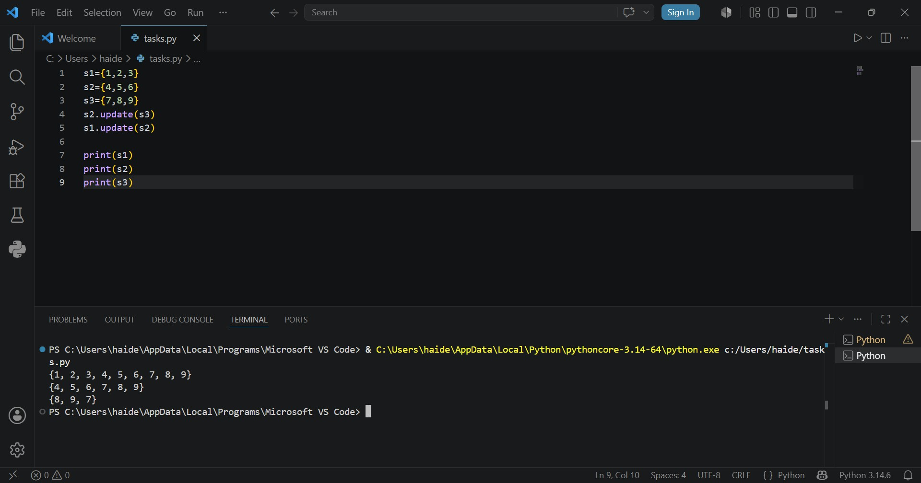
Task 10:

Create three sets with some common elements. Find their intersection using set.intersection() and print the result. Also demonstrate intersection_update() by modifying the first set.
Result:
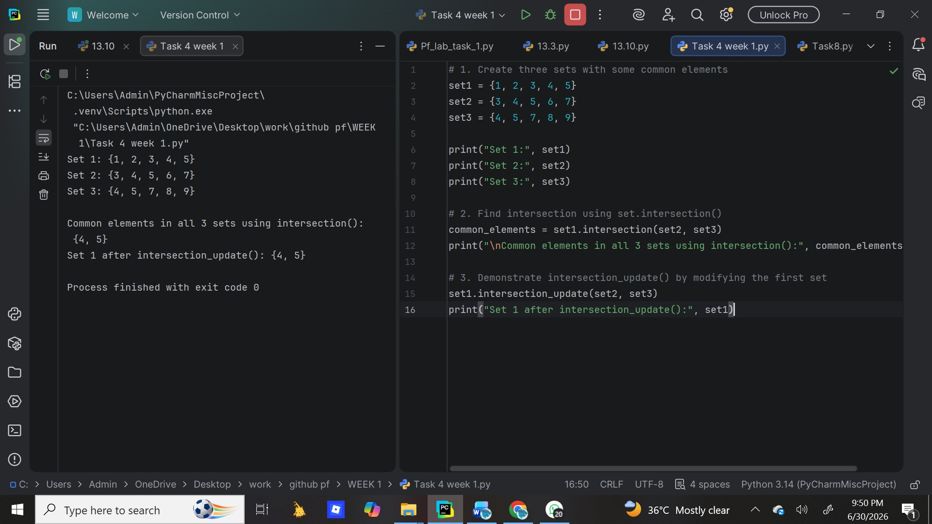

Task 11:
Create two sets. Check if they have any common elements using the isdisjoint() method and print the boolean result.

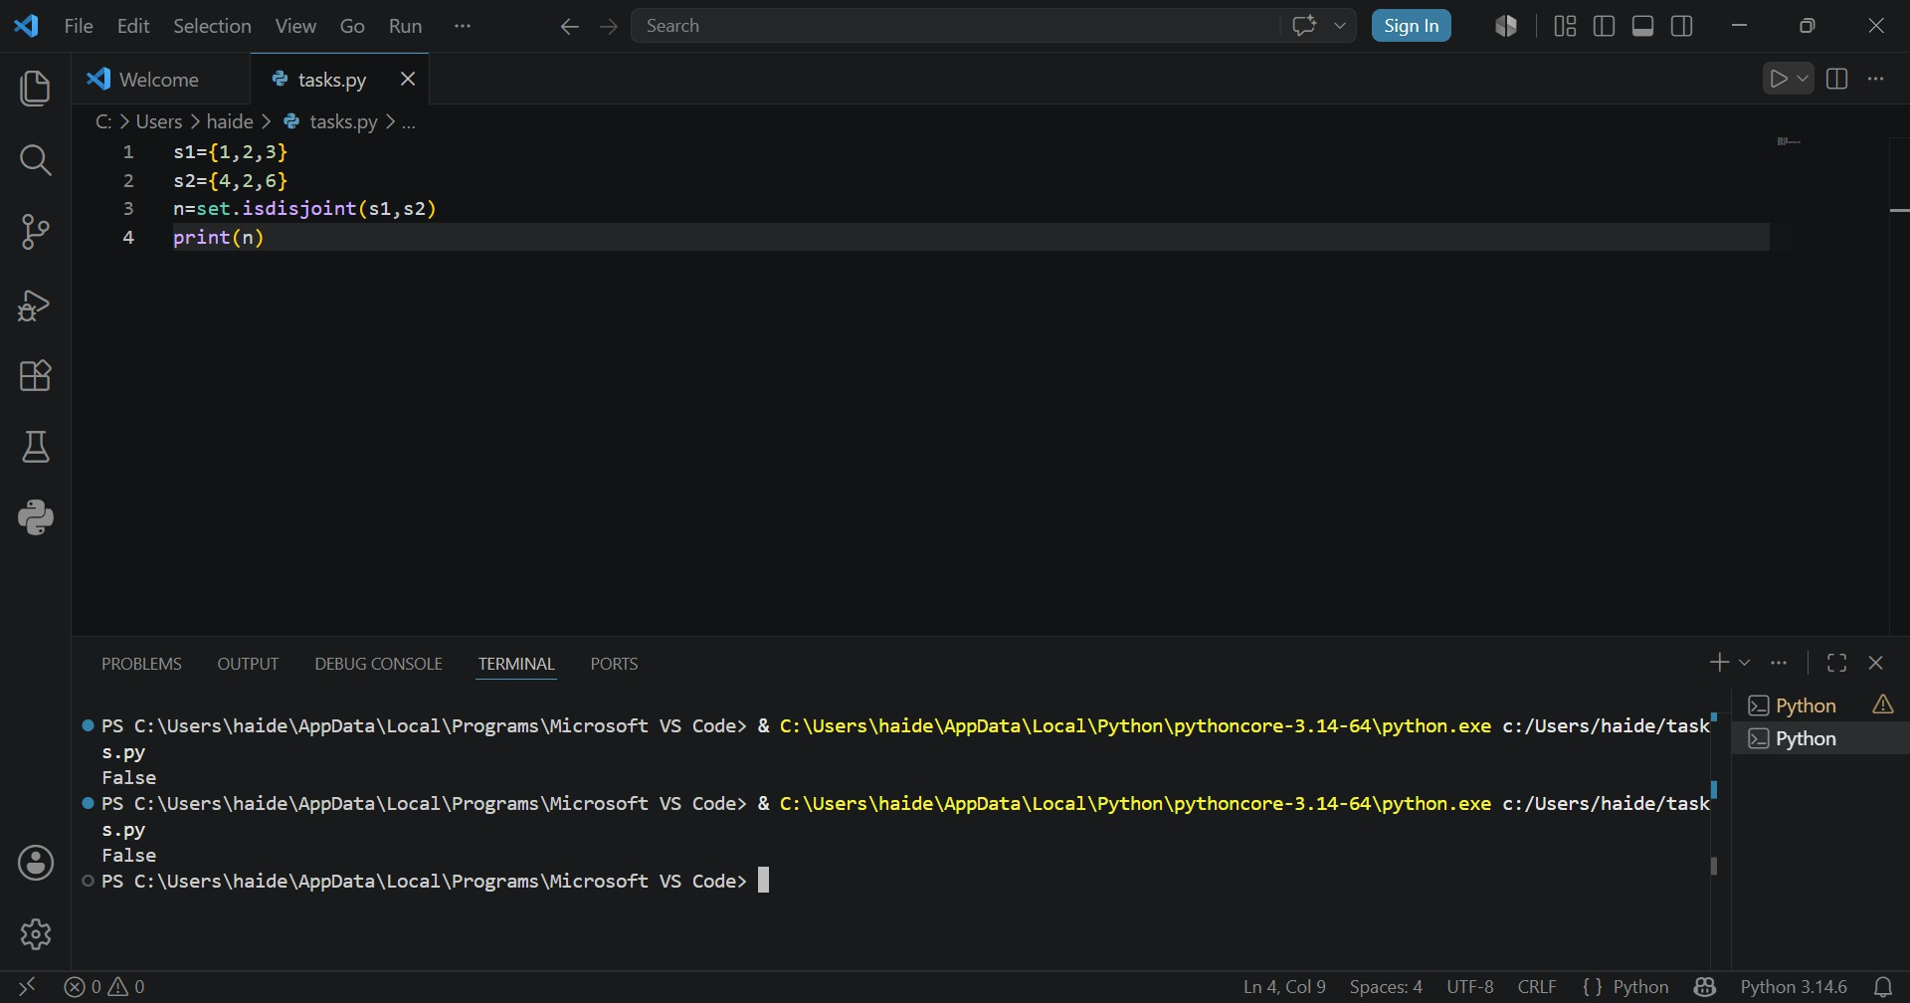
Result:

Task 12:
Create a set with duplicate values and observe that duplicates are automatically removed. Then create another set with duplicate string values and print both sets. Finally, convert a list [1,2,3,7] into a set using the set() constructor and print the resulting set.

Result:
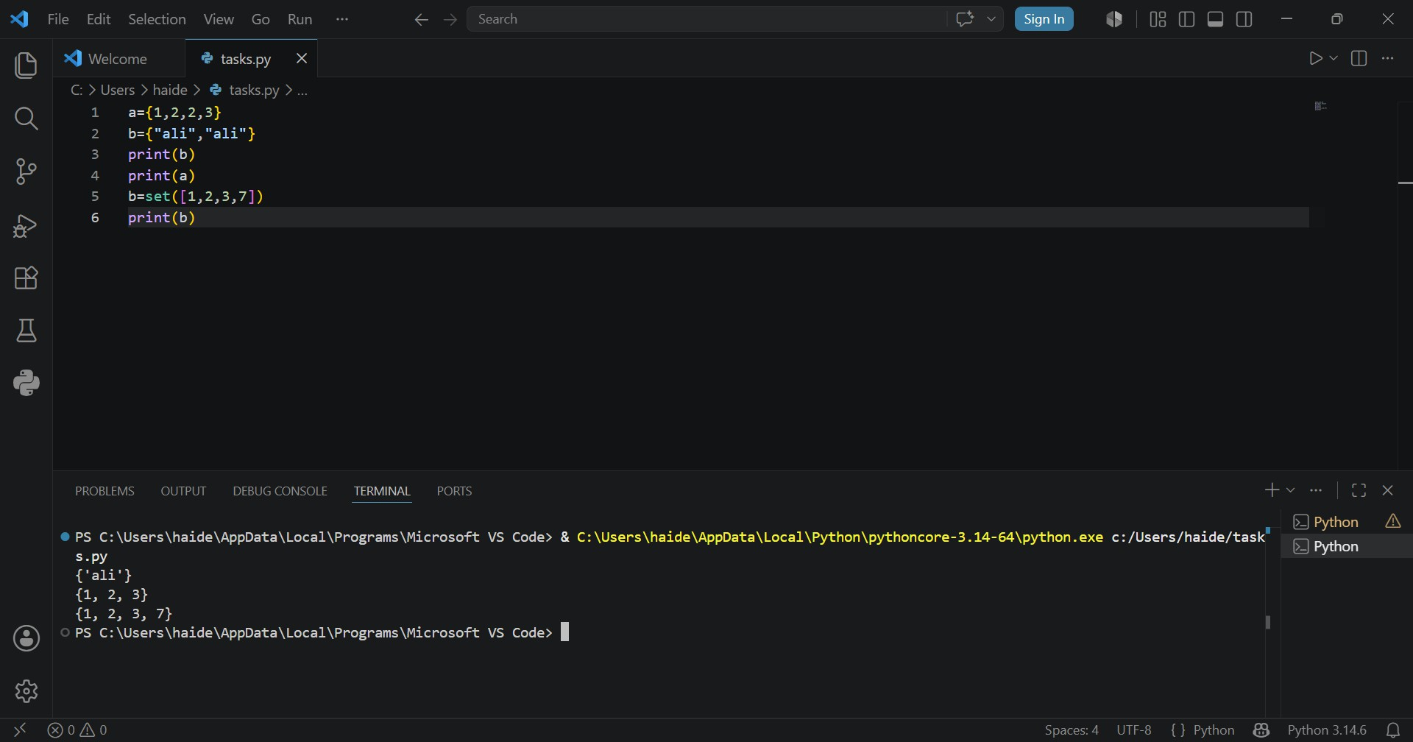

Conclusion:
In this lab we learned that Dictionary and Set are both very useful built-in data structures in Python.Dictionary helps us store related data with labels. It is best when we need to map a key to a value, like roll no to student name.
Set helps us store only unique items and perform fast membership checks and mathematical operations.Both structures make our programs more efficient.
Dict is used for structured data storage, while Set is used for uniqueness and set logic.Together, dict and set reduce code complexity and improve performance compared to using only lists.

